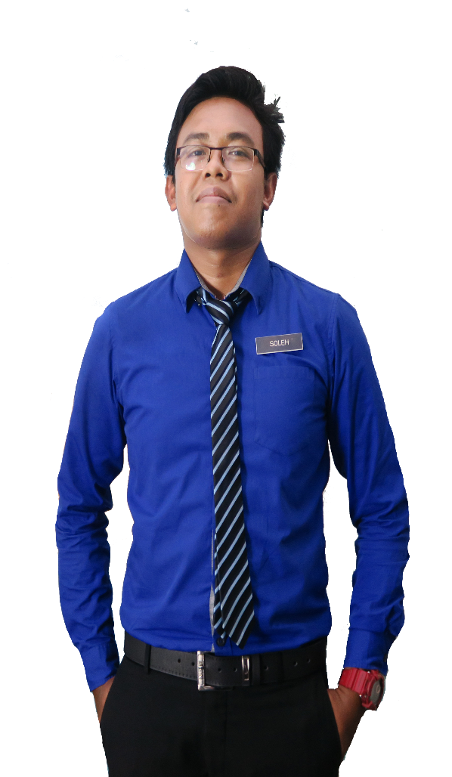

Prof. Dr. Mohamad Suffian Mohamad

Academic Advisor

Kolej Kediaman Tun Syed Zahiruddin

Universiti Teknologi Mara

[suffian_annuar@um.edu.my](mailto:suffian_annuar@um.edu.my)

+60160-2190 5697

**REFERENCE**

**PERSONAL SKILLS**

DISCIPLINE

HARD WORK

TEAMWORK

COMMUNICATION

CREATIVE

**SKILLS**

DREAMWEAVER

SPSS

AFTER EFFECT CS6

PHOTOSHOP CS6

MICROSOFT OFFICE

Lecturer

resumecreative@yahoo.com

Creative Resume, 74000 Bandar Puncak Alam,Selangor

013-2805916

* Graphic Design Award 2015, Kuala Lumpur
* Anugerah Guru Cemerlang SMK Bandar Baru Sungai Buloh 2016
* Larian Hari Sukan Negara 2016, UiTM Kampus Puncak Alam
* Mount Kinabalu Hiking Expedition
* Volunteer for SUKMA 18, Pahang Darul Makmur
* Creative and Innovation Awards 2017
* Anugerah Perkhidmatan Cemerlang Pegawai Pendidikan Daerah Gombak 2016
* Pengerusi Kelab Keusahawanan Belia Daerah Gombak 2015

**ACHIEVEMENT**

**SEKOLAH MEN KEB BANDAR BARU SUNGAI BULOH**

Sijil Pelajaran Malaysia

2012-2014

Science Stream (Module II)

CGPA: 3.91

**KOLEJ MATRIKULASI KEDAH, CHANGLUN**

2012-2014

Bachelor of Education in Science (Hons) Chemistry

CGPA: 3.94

2012-2014

**UNIVERSITI TEKNOLOGI MARA KAMPUS PUNCAK ALAM**

Master of Education in Science

CGPA: 3.93

**UNIVERSITI TEKNOLOGI MARA SHAH ALAM, SELANGOR**

2012-2014

**EDUCATION**

**EXPERIENCE**

2012-2014

Teacher

Implements curriculum objectives and goals using effective teaching techniques and materials. Develops, in a cooperative manner with the principal and curriculum facilitators, a plan for the improvement and enrichment of instruction.

**SEKOLAH MEN KEB KUALA TEKAL, PAHANG**

Implements curriculum objectives and goals using effective teaching techniques and materials. Develops, in a cooperative manner with the principal and curriculum facilitators, a plan for the improvement and enrichment of instruction.

**SEKOLAH MEN KEB BANDAR BANDAR BARU SUNGAI BULOH**

Teach at undergraduate and graduate level in areas allocated by the Head of Department and reviewed from time to time by the Head of Department. Carry out research and produce publications, or other research outputs, in line with personal objectives agreed in the Staff review process.

Teacher

2012-2014

2012-2014

**UNIVERSITI TEKNOLOGI MARA SHAH ALAM, SELANGOR**

**MUHD SOLEH**

Master’s degree in Science with four years’ experience teaching high school Science, Chemistry, and Additional mathematic. Certification in teaching Science and also professional in graphic design and video editor.

**GRAPHIC DESIGNER & TEACHER**

RESUME